**Exploring Weather Trends**

**Step 1** – Get the data with the following query

WITH unified AS (  
 SELECT city  
 , country  
 , year  
 , avg_temp  
 FROM city_data  
  
 UNION  
  
 SELECT 'Global' AS city  
 , 'World' AS country  
 , year  
 , avg_temp  
 FROM global_data  
)  
SELECT *  
 , AVG(avg_temp) OVER (PARTITION BY city ORDER BY year) full_width_moving_avg  
 , AVG(avg_temp) OVER ( PARTITION BY city ORDER BY year  
 ROWS BETWEEN 10 PRECEDING AND CURRENT ROW ) ten_days_moving_average  
FROM unified

As you may have notice, I unified two tables (city_data, global_data) in order to simplify the source dataset. This is a kind of database denormalization.

Also added another field moving_avg in that way solving the problem with moving average.

I also added another moving average field which has 10 days length.

**Step 2** – used the result csv file as data source in Tableau workbook which is also published in [my Tableau public profile](https://public.tableau.com/profile/aramayis.grigoryan5969?fbclid=IwAR3mD6mGOxTmRxu5r8jnY8DvxbutGtdsRr8ImAF73yZ0SQOMKpTAHZ41G1s#!/vizhome/WeatherTrendsWorkbook/WeatherTrendsDashboard?publish=yes). 🡨 PLEASE CLICK ON THIS LINK TO SEE THE ENTIRE DASHBOARD.

**Step 3** – Dashboard

View 1: Moving Average lines

­­­­­­­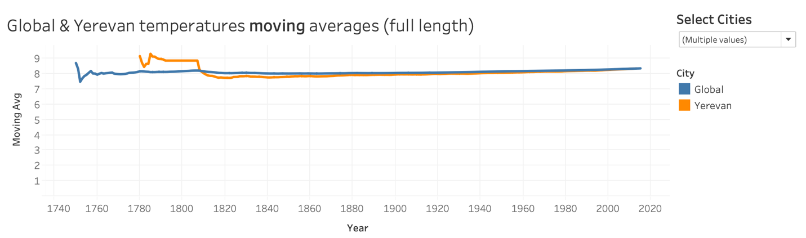

Looking at these lines, we can conclude that Yerevan a little bit colder that the average global temperature.

I have also added a filter by which you can compare any other country you’d like.

I also created a dashboard for 10 years period.

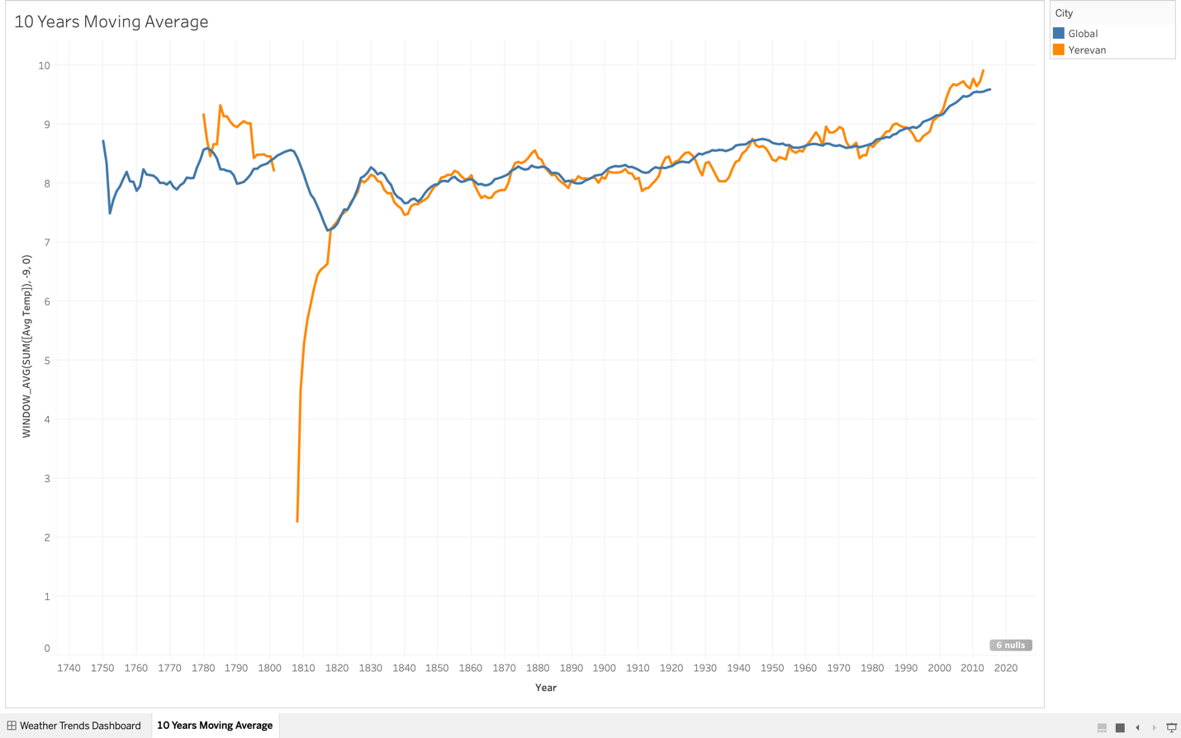

View 2: Correlation between the chosen city and the global yearly average temperature.

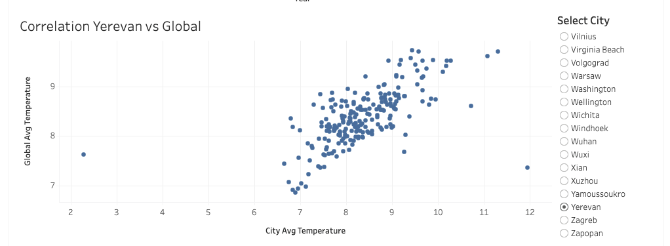

As we can see, our city’s temperature has positive correlation with the global temperature.

View 3: In Tableau, I added a calculated field which’s value was depended on the chosen cities and the global warmings comparison.

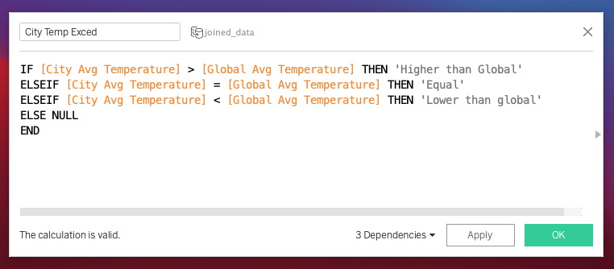

So that I will be able to count how many times each city’s avg temperature exceeded and was lower than the global one.

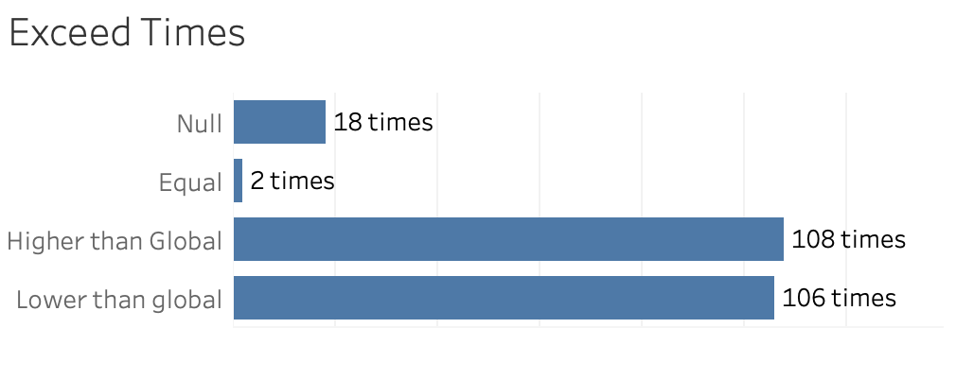

The interesting fact is that temperature in Yerevan has been higher than the global more times than lower (but the moving avg was a bit lower). This means that when it’s cold in here, its too cold, but when it’s warm, it’s not so hard ☺

View 4: Average temperature (not the moving one) compared with the global one to see the fluctuations which’s importance we understood from view 3.

